# Create a News Room Page component using the base page component

In AEM, a **pag e component** is the foundation for templates and pages. To create a **News Room Page**, we **extend the base page component**, so it inherits common structure like head.html, body.html, and page.html.

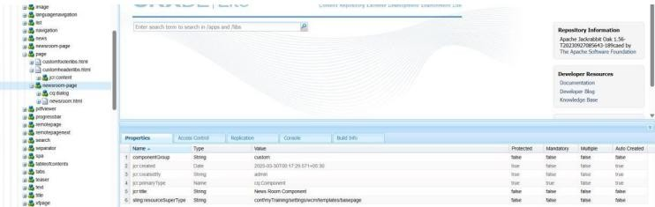

# Create a News Room Page Component using the Base Page Component

* + Default News Image
  + "Read More" CTA Text

You’ll add a **custom tab** in the page dialog that allows authors to configure news-specific settings.

Add "Read More" CTA for News Articles

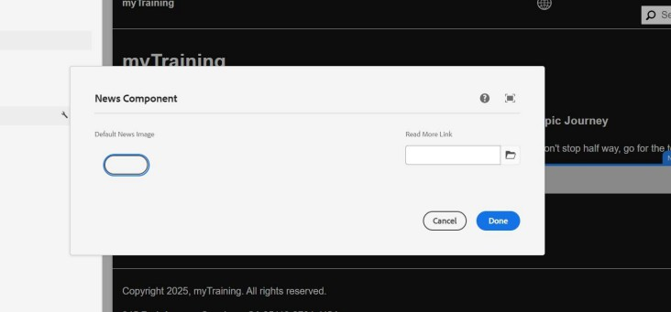

# Create a News Room Template Type using the News Room Page Component

Create News Room Template Type using News Room Page Component Steps to Implement:

* Go to AEM > Tools > General > Template Types.
* Create a new Template Type named News Room Template Type.
* Set the Allowed Resource Type as yourproject/components/page/newsroompage.

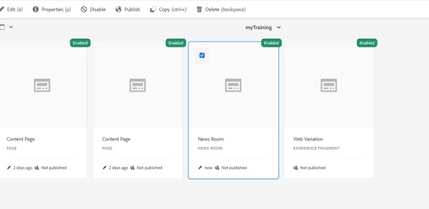

How to Verify:

* Go to Template Editor and check if the template type appears.
* Try creating a template using this type.

# Create a News Room Template using News Room Template Type

## Go to Tools > General > Templates

* + Click **Create**
  + Choose **News Room Template Type**
  + Name it: News Room Template
  + Configure **Initial Content**, **Policies**, and **Structure**
  + Enable the template How to Verify:
* Check if the template appears under Templates in AEM.
* Create a page using this template and verify the structure.

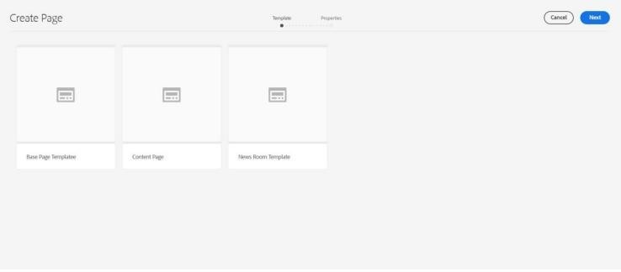

# Apply the styling to news/hello world component from ui.frontend folder

In AEM SPA/modern projects, all styles are managed in ui.frontend. We'll:

* + Create a SCSS/CSS file
  + Import it into the main style file
  + Deploy to your component

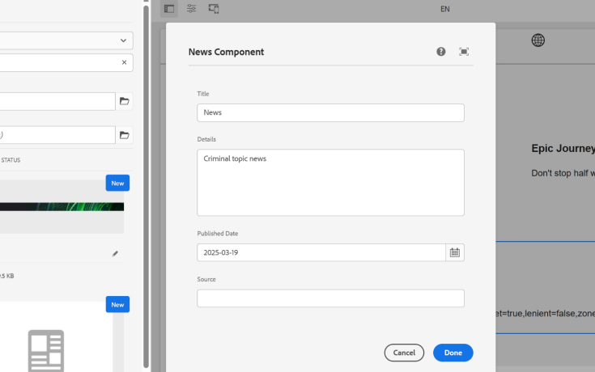

# Additionally, create a custom style to apply above styling to hello world or news component

AEM supports **style system** in editable templates to let authors choose styles like "Green Title", "Yellow Detail", etc.

In your **Policy** dialog (via template editor):

* 1. Go to Structure > Select News component

## Click Policy (screwdriver icon)

* 1. Under **Styles**, add:
     + Title: “Styled News”
     + Class: cop-news-component

